IC 4N35 Optocoupler
CP030
Image:
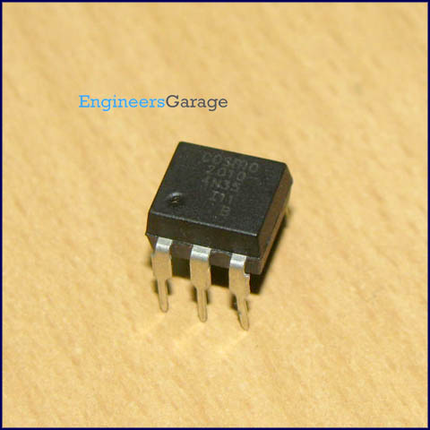
DataSheet:
4N35.pdf
4N35 is an optocoupler integrated circuit in which an infrared emitter diode drives a phototransistor. They are also known as optoisolators since they separate two circuits optically. These are used to couple two circuits without any ohmic contact. They allow one of the circuits to switch another one while they are completely separate. The first circuit is connected to IR diode while the other circuit with the phototransistor. The isolation ensures that no damage occurs in either of the circuits while the other one has a fault.

An optocoupler is analogous to a relay which isolates two circuits magnetically. They differ with relays in the sense that they are smaller in size and allow fast operation. 4N35s are commonly used in interfacing an electronic circuit with the parallel port of a computer.
Pin Diagram:
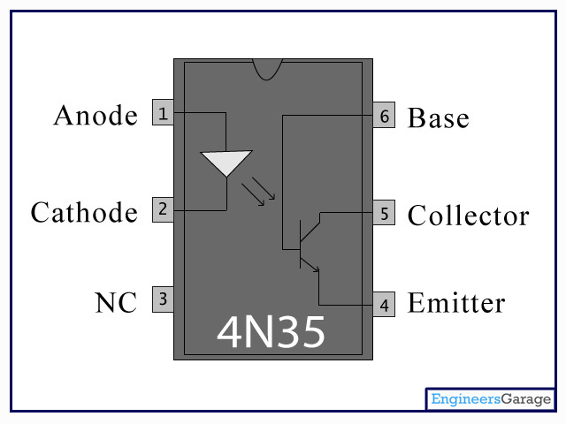
Pin Description:

Pin No | Function | Name
1 | IR diode’s anode | Anode
2 | IR diode’s cathode | Cathode
3 | Not connected | NC
4 | Phototransistor’s emitter | Emitter
5 | Phototransistor’s collector | Collector
6 | Phototransistor’s base | Base

